**Chapter 1**

**INTRODUCTION TO REACT.JS**

* 1. **Introduction**

Web development has evolved significantly over the years, with an increasing demand for dynamic, interactive, and efficient user interfaces. Traditional web development relied heavily on manipulating the **Document Object Model (DOM)**, which could be inefficient, especially for complex applications. To address these challenges, modern front-end libraries like **React.js** have emerged, providing a structured and optimized approach to building user interfaces.

**What is React.js?**

React.js is an open-source JavaScript library developed by **Facebook** in 2013. It is primarily used for building fast, interactive, and scalable web applications. React simplifies UI development by introducing a **component-based architecture**, where the user interface is broken down into independent and reusable components. These components can manage their own state and logic, making it easier to develop and maintain applications.

**Why React.js?**

Before the introduction of React, developers often used frameworks like PHP, jQuery, and AngularJS to create dynamic web applications. However, these traditional approaches had several limitations, such as poor performance, difficulty in managing UI state, and complex debugging processes. React was designed to solve these problems by:

* Improving performance through the use of a Virtual DOM, which reduces unnecessary re-rendering.
* Enhancing maintainability with reusable components, making code more modular and easier to manage.
* Simplifying state management by enforcing a one-way data flow, which improves predictability and debugging.

Due to these advantages, React.js has become one of the most widely used front-end libraries, powering major applications such as Facebook, Instagram, WhatsApp Web, Netflix, and Airbnb. It is now a fundamental technology in modern web development, widely adopted by developers and organizations worldwide.

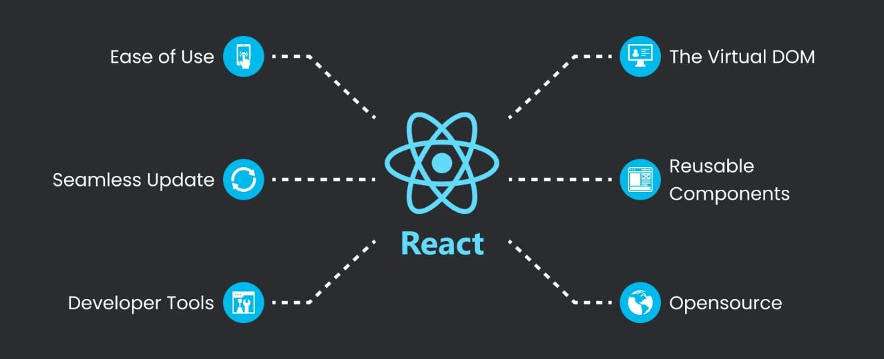

* Ease of Use – Simple API and JSX make development faster and more user Friendly.
* The Virtual DOM – Improves performance by updating only necessary parts of the real DOM.
* Seamless Update – Dynamic component updates without full page reloads.
* Reusable Components – Modular structure allows easy reuse and better maintainability.
* Developer Tools – Powerful debugging tools like React DevTools enhance development.
* Open Source – Free, widely supported, and continuously improved by the community.
  1. **Key Features of React.js**
* **Component-Based Development**

React follows a component-based architecture, meaning that the user interface is divided into small, reusable components. Each component is self-contained, with its own logic, structure, and state. This approach makes development more modular, improves code maintainability, and enhances scalability.

**Benefits of Component-Based Development**

1. Reusability – Components can be used multiple times throughout an application, reducing redundancy.
2. Easier Maintenance – Updates and modifications can be done in a single component without affecting others.

* **Virtual DOM**

The Document Object Model (DOM) represents the structure of a webpage. Traditionally, modifying the DOM directly leads to performance issues, as frequent updates slow down rendering. React solves this problem using the Virtual DOM, which optimizes the update process.

**How the Virtual DOM Works**

1. React creates a Virtual DOM, a lightweight copy of the actual DOM.
2. When a change occurs, React first updates the Virtual DOM, instead of modifying the real DOM immediately.
3. React then compares the updated Virtual DOM with the previous version using a process called reconciliation.
4. Only the necessary parts of the real DOM are updated, leading to faster rendering and better performance.

**Advantages of the Virtual DOM**

* Improved Performance –Minimizes direct interactions with the real DOM, reducing unnecessary re-renders.
* Efficient Updates – Only changed elements are updated, rather than the entire webpage.
* Smooth User Experience – Applications remain fast and responsive, even with complex UI interactions.

.

* **One-Way Data Flow**

React follows a unidirectional (one-way) data flow, meaning that data moves in a single direction from parent components to child components. This structured approach simplifies state management, making applications more predictable and easier to debug.

**Why One-Way Data Flow is Important**

* Predictability – Since data flows in only one direction, it’s easier to track and manage updates.
* Easier Debugging – Developers can quickly identify and fix issues by tracing data changes.
* Better State Management – React integrates well with state management tools like Redux, ensuring efficient handling of dynamic application states.

**How It Works**

1. Parent components pass data to child components in a one-way direction.
2. Child components can display the data but cannot modify it directly.
3. If data needs to be updated, child components send events to the parent, which updates the state.
4. The new state is passed down to the child components, ensuring consistency.

**Benefits of One-Way Data Flow**

* Reduces unexpected side effects, making the application more stable.
* Prevents accidental data modification, leading to better control over state changes.
* Improves code maintainability by enforcing clear communication between components.

**1.3 Conclusion**

React.js has revolutionized web development with its flexible, efficient, and scalable approach to building user interfaces. Its component-based architecture enhances code reusability, and the Virtual DOM improves performance by minimizing unnecessary updates. React one-way data flow streamlines state management, making applications more predictable and easier to debug.

React helps developers build fast and interactive apps without slowing them down. It’s very popular, well-supported by a big community, and keeps improving. Because of this, React is a go-to tool for creating smooth and efficient websites, no matter how big or small the project is.